Object Oriented Programming

Spring 2022/2023

Sheet1 (Struct)

**Q1. Assume that you have the following definition of a struct.**

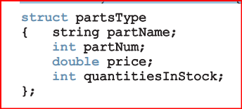

1. Declare an array, inventory, of 10 components of type partsType. Assume that the variable length indicates the number of elements in inventory.
2. Write a C++ code to initialize each component of inventory as follows: partName to null string, partNum to -1, price to 0.0, and quantitiesInStock to 0.
3. Write the definition of a void function that can be used to input data in a variable of type partsType. Also write a C++ code that uses your function to input data in inventory.
4. Write a function that uses a loop to output the data stored in inventory.

**Q2. Suppose that you have the following definitions:**

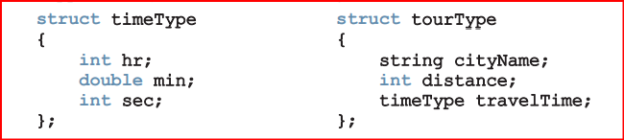

1. Declare the variable destination of type tourType.
2. Write C++ statements to store the following data in destination: cityName—Chicago, distance—550 miles, travelTime—9 hours and 30 minutes.
3. Write the definition of a function to output the data stored in a variable of type tourType.
4. Write the definition of a value-returning function that inputs data into a variable of type tourType.
5. Write the definition of void function with a reference parameter of type tourType to input data in a variable of type tourType.